For some items, specific brand names are given. Please buy these brands if possible.

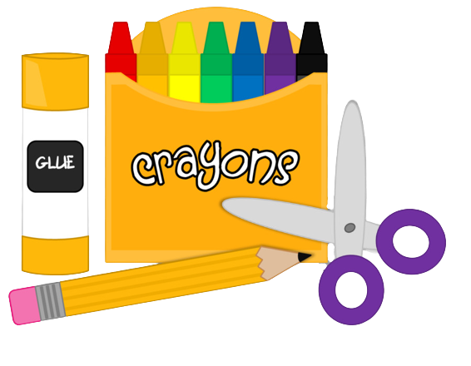
Although they may cost a bit more, the cost is less in the long run! We have learned from experience that these brands work better, sharpen easier, and last longer!

Please label the following with your child’s name:
- 1 pair 5” scissors, label with name
- 1 watercolor paint set (Crayola preferred) label with name
- 1 small water bottle labeled with the student's name. This will be sent home to be washed daily.
- 1 pair of headphones, labeled with the student’s name.
The following items do NOT need to be labeled:
- 3 boxes of 24 ct. crayons (Crayola preferred)
- 12 #2 pencils (Dixon Ticonderoga preferred)
- 6 glue sticks (Elmer’s preferred, NOT scented)
- 2 boxes of washable, broad tip markers (Crayola preferred, no fine tip)
- 1 box of colored pencils (Crayola preferred)
- 1 (4 pack) THIN, BLACK Expo dry erase markers (no colors please)
- 2 sturdy plastic folders (with no clasps)
- I box Kleenex
- Antibacterial, disinfecting wipes (for tables & surfaces)
- Baby wipes (for hands)
- 1 box of bandaids
- Last name A-H –1 ream white card stock
- Last name I-O –1 ream colored card stock
- Last name P-Z –1 ream colored paper
*The requested items may be collected by the teachers to be used at their discretion at the beginning of the school year and thus are technically considered “donations.” These items are important to our teachers' ability to provide your children with a practical learning experience and are strongly encouraged. We appreciate your support in ensuring that we can empower all students' success.

